# Alejandro Castañon D.

WhatsApp [**+52 5619333339**](http://www.wa.me/5215572050743)

[**alejandrocastanondiaz@gmail.com**](mailto:alejandrocastanondiaz@gmail.com?Subject=Quote)

[**https://alexcd2000.com/**](https://alexcd2000.com/)



# Mexico City, 21st January 2023

**Quote for**

**Dorathy Williams**



|  |  |  |  |  |
| --- | --- | --- | --- | --- |
| **QTY** | **DESCRIPTION** | **UNIT** **PRICE** | **TIME FRAME** | **AMOUNT** |
| 1 | Weekly Coding Services. | 220.00 | ONCE | 220.00 |

**Total: $220.00**

* Prices are in U.S. Dollars

* Prices are in U.S. Dollars

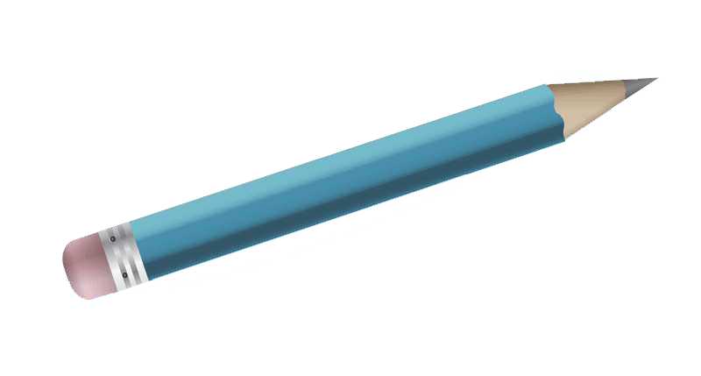

Please, **let me know any enquiries** you might have, my contact details are on the **top left corner of this page.**

**Terms & Conditions**

All jobs require half in advance and half upon completion, unless stated otherwise.

**\*If any changes required, please use my contact links on the upper left corner of this page**

**Payment methods**

* **Bitcoin/XRP Accepted!** use this link: [**https://alexcd2000.com/#crypto**](https://alexcd2000.com/#crypto) (use exchange rate of the day)
* **Bank Wire** in MXN, USD, EUR, GBP, AUD, CAD, JPY or AED use this link: <https://alexcd2000.com/#bankwire> (and choose the preferred currency).
* **PayPal** (add +5%) use this link: [**https://www.paypal.me/alexcd2000/123USD**](https://www.paypal.me/alexcd2000/123USD) (write the right amount)

**Thanks for your Business!**