Alejandro Castañon D.
WhatsApp +52 5619333339
alejandrocastanondiaz@gmail.com
https://alexcd2000.com/

INVOICE NO. 2

BILL TO INVOICE DATE 8th May 2023
Capeles LLC
DUE DATE 12th May 2023

DESCRIPTION | QTY | UNIT PRICE | AMOUNT
Coding Services 1st to 7th May 2023 | 36.5 hours | 38.00 | 1,386.00

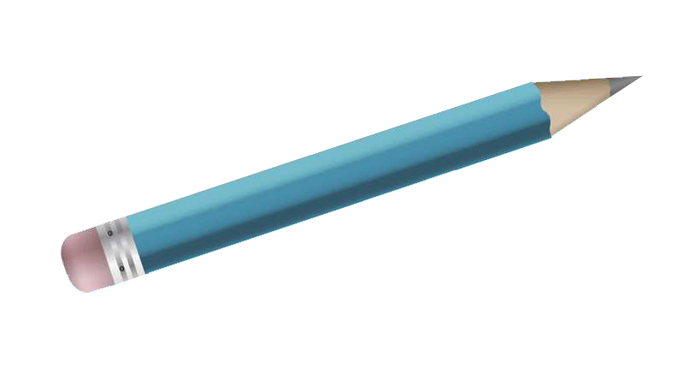
Total: $1,386.00
* Prices are in U.S. Dollars

* Prices are in U.S. Dollars

Payment methods
- Bitcoin/XRP Accepted! use this link: https://alexcd2000.com/#crypto (use exchange rate of the day)
- Bank Wire in MXN, USD, EUR, GBP or AUD use this link: https://alexcd2000.com/#bankwire (choose the preferred currency).
  - Wire in USD inside U.S.A. only, no SWIFT transfers yet...
Bank: Lead Bank
Name: Alejandro // Last names: Castanon Diaz
ACH & Wire Routing Number: 101019644
Account Number: 218838809179
Account Type: CHECKING
Bank address (if needed): 21750 Hardy Oak Blvd Ste, San Antonio, Texas 78258, United States
- Card Payment (add +5% to the amount) with Stripe use this link: https://alexcd2000.com/payment.php (enter amount and preferred currency)
Thanks for your Business!

