# Alejandro Castañon D.

WhatsApp [[**+52 5619333339**](http://www.wa.me/5215572050743)](http://www.wa.me/5215572050743)

[**alejandrocastanondiaz@gmail.com**](mailto:alejandrocastanondiaz@gmail.com?Subject=Quote)

[**https://alexcd2000.com/**](https://alexcd2000.com/)

# INVOICE NO. 1

# Date: 28th June 2024

**BILL TO FROM**

**Alejandro Castañon Diaz**

**Parque lira 79 int. 503,**

**CDMX, Mexico C.P. 11850**

**RFC CADA910306T32**

**DREILAUT UG**

**Mozartstraße 17**

**19053 Schwerin**

**VAT-ID: DE300809494**



|  |  |  |  |
| --- | --- | --- | --- |
| **QTY** | **DESCRIPTION** | **UNIT** **PRICE** | **AMOUNT** |
| 32.1 | Coding Services by hour period May to June 2024 | 35.00 | 1,123.50 |

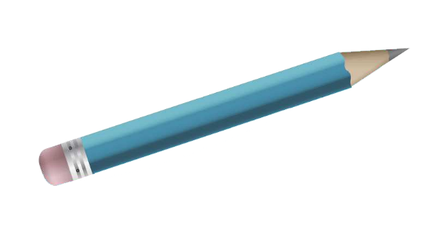

**Total: 1,123.50**

* Prices are in Euros

* Prices are in U.S. Dollars

**Payment methods**

* **Bitcoin/XRP/USDT Accepted!** use this link: [**https://alexcd2000.com/#crypto**](https://alexcd2000.com/#crypto) (use exchange rate of the day)
* **Bank Wire** in MXN, USD, EUR, GBP, AUD, CAD, JPY or AED use this link: <https://alexcd2000.com/#bankwire> (and choose the preferred currency).
  + for Wire in Euros

* Only payments for business transactions from business accounts are supported  
* Use for local bank transfers within the EU in EUR via the SEPA Credit Transfer (SCT) or SEPA Instant Credit Transfer (SCT Inst) network  
**Bank:**Banking Circle S.A.  
**BIC:**BCIRLULL  
**IBAN:**LU224080000026959524  
**Name:** Alejandro // **Last names:** Castanon Diaz  
**Bank address (if needed):** 2, Boulevard de la Foire L-1528 LUXEMBOURG

* **PayPal** (+5% fee) use this link (credit card accepted): [**https://www.paypal.me/alexcd2000/1179eur**](https://www.paypal.me/alexcd2000/1179eur)

**Thanks for your Business!**