# Alejandro Castañon D.



WhatsApp [**+52 5619333339**](http://www.wa.me/5215572050743)

[**alejandrocastanondiaz@gmail.com**](mailto:alejandrocastanondiaz@gmail.com?Subject=Quote)

[**https://alexcd2000.com/**](https://alexcd2000.com/)

# INVOICE NO. 2

**BILL TO** **INVOICE DATE 8th May 2023**

**Capeles LLC**

**DUE DATE** **12th May 2023**

|  |  |  |  |
| --- | --- | --- | --- |
| **DESCRIPTION** | **QTY** | **UNIT** **PRICE** | **AMOUNT** |
| Coding Services 1st to 7th May 2023 | 36.5 hours | 38.00 | 1,386.00 |



**Total: $1,386.00**

* Prices are in U.S. Dollars

* Prices are in U.S. Dollars

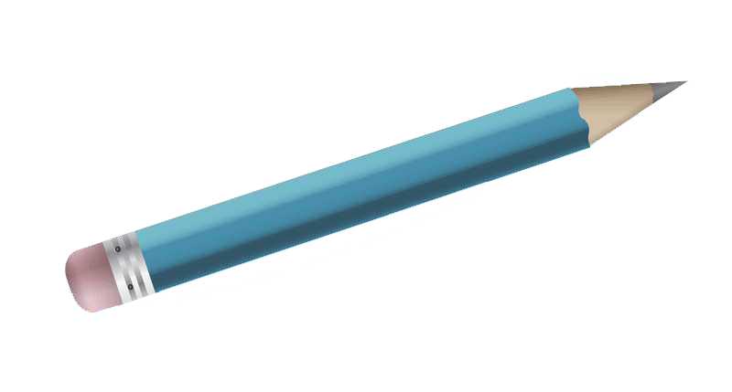

**Payment methods**

* **Bitcoin/XRP Accepted!** use this link: [**https://alexcd2000.com/#crypto**](https://alexcd2000.com/#crypto) (use exchange rate of the day)
* **Bank Wire** in MXN, USD, EUR, GBP or AUD use this link: <https://alexcd2000.com/#bankwire> (and choose the preferred currency). For other currencies use [**Wise.com**](https://wise.com/invite/ath/alejandroc1519) for international transfers at low fees.
  + **Wire in USD inside U.S.A. only, no SWIFT transfers yet...**

**Bank: Lead Bank  
Name: Alejandro // Last names: Castanon Diaz  
ACH & Wire Routing Number: 101019644  
Account Number: 218838809179  
Account Type: CHECKING  
Bank address (if needed): 21750 Hardy Oak Blvd Ste, San Antonio, Texas 78258, United States**

* **PayPal** (add +5%) use this link: [**https://www.paypal.me/alexcd2000/123USD**](https://www.paypal.me/alexcd2000/123USD) (write the right amount)

**Thanks for your Business!**